CAR RENTAL SERVICE

PROJECT BY:

MUHAMMAD FAHAD (FA21-BCS-124)

MUHAMMAD QADEER ANJUM (FA21-BCS-133)

DESCRIPTION:

Our app is made for users to select cars and enjoy their trips.

Management will see all the records of rented cars, user information, and payment.

Our app is developed for the ease of User and the management.

Firstly, User will have to sign up.

If it has already signed up then he will login.

We will also provide the feature of forget password.

First scene will be the title page showing name of our app.

Second scene, there will be a list of cars with prices mentioned from which user can select any of his Favorite car.

After selecting his car, he will select number of days.

Rent of each car will be shown on the same scene.

At 3rd Scene, he will see the total amount he has to pay to get the car.

Finally his car will be rented.

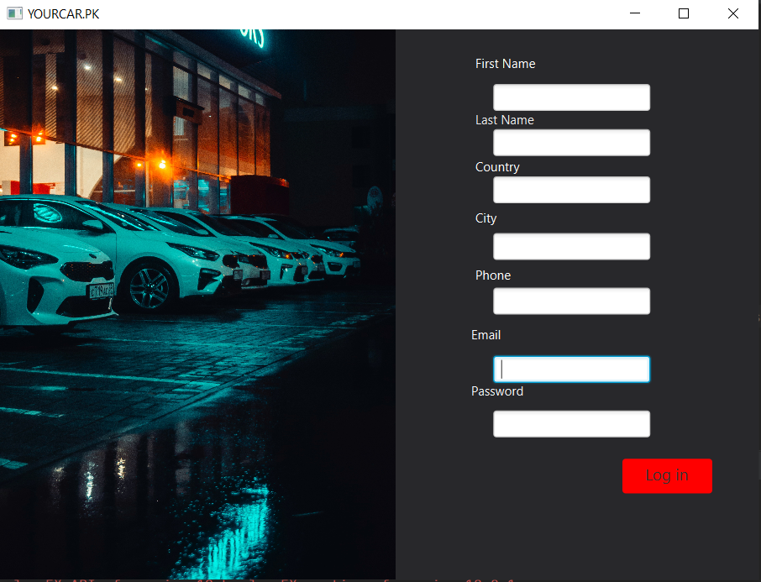

User will enter his first name, last name, country, city, phone number, email and password.

After signing in, he will come to login page.

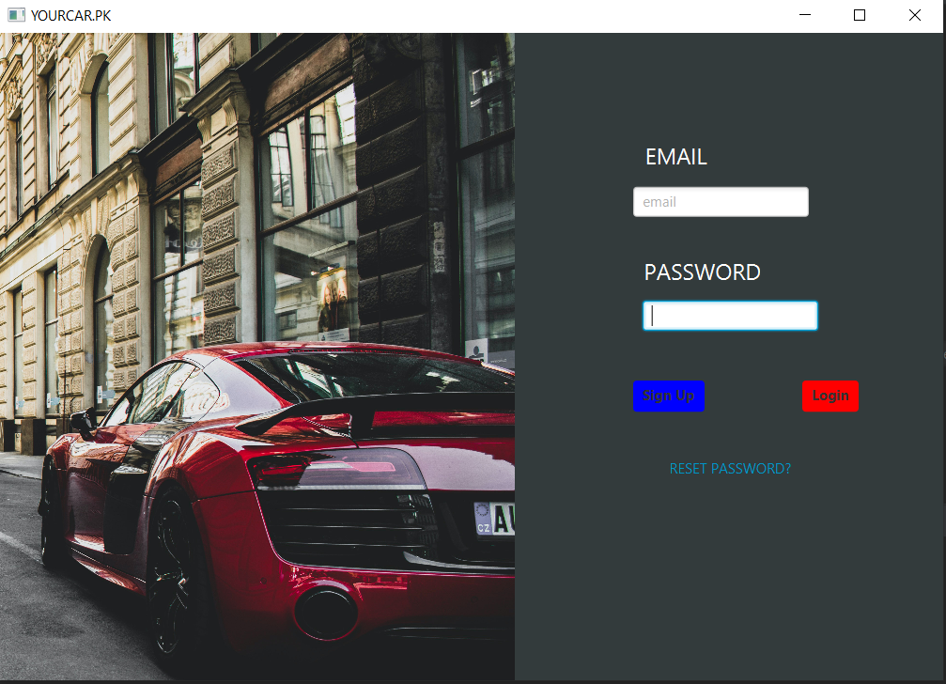

If user by any chance forget the password, he can use the feature of forget password. A pin will be sent to his registered email. After entering the pin, he will enter new password and can login easily.

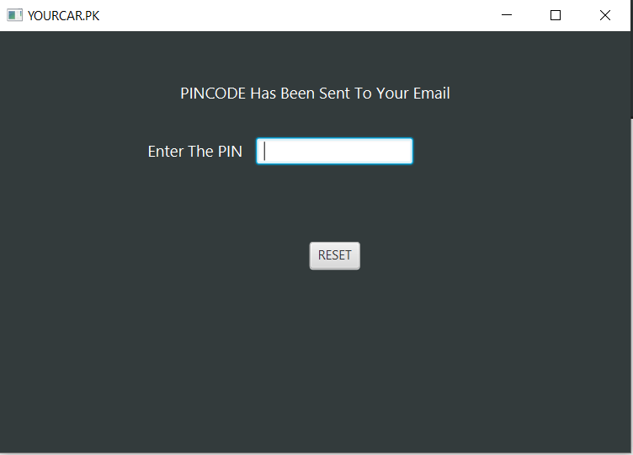

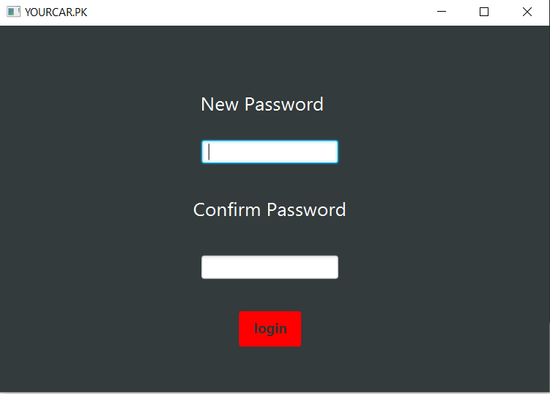

After successfully log in, he will move to the home page.

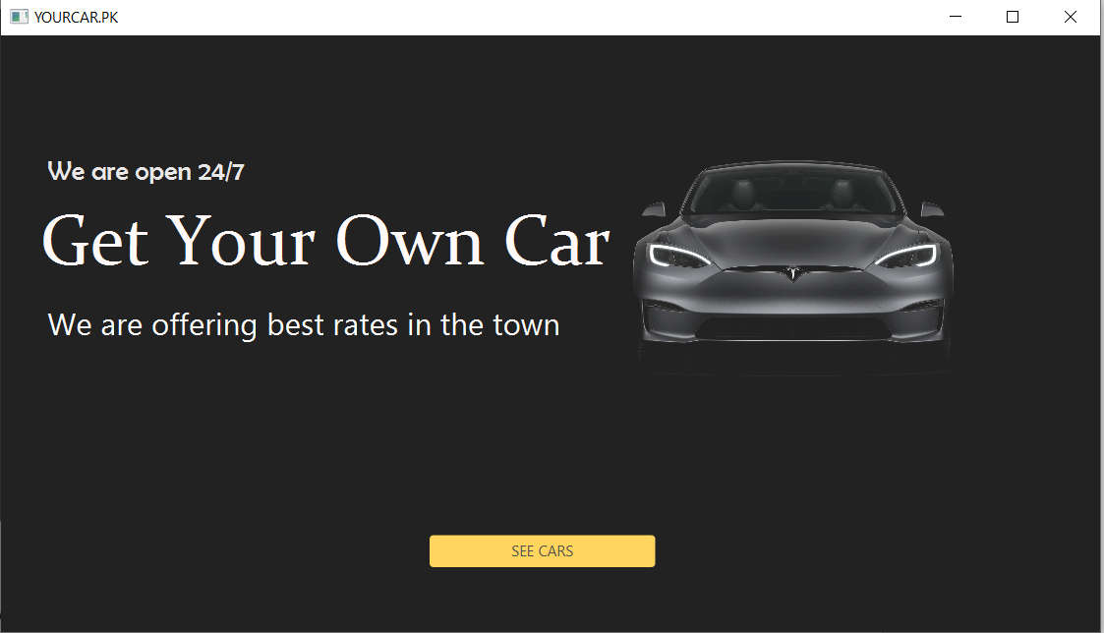

At home page, he will click the button “SEE CARS” and will the list of cars from which he can select car of his choice.

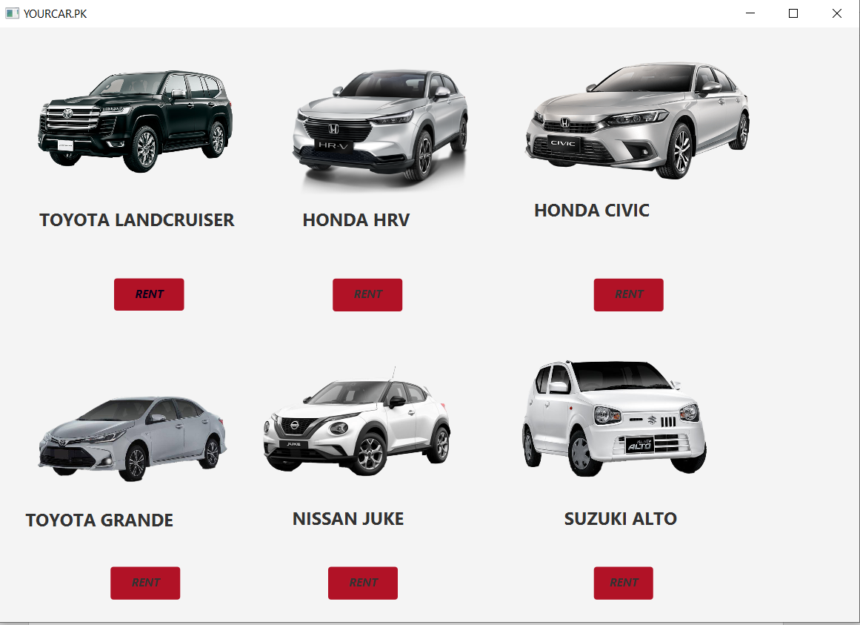

Suppose he want to rent land cruiser, he will click on rent and will see rent per day.

He can also select number of days for each car.

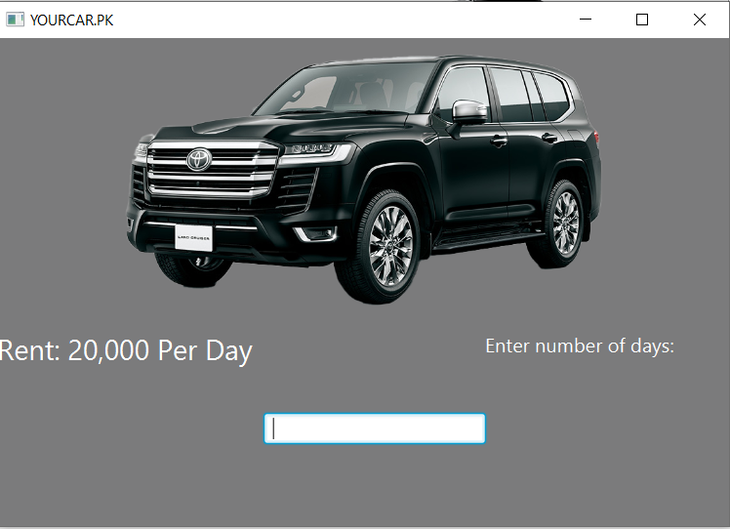

Finally he will move towards the billing page.

He will pay the amount and car will be given to him.

TECHNOLOGIES USED:

* **INTELLI J**
* **JAVA FX**
* **SCENE BUILDER**